Single Line to Ground Fault Calculation
Fault location: Bus-0002

One-line diagram with the input data and per-unit impedances:

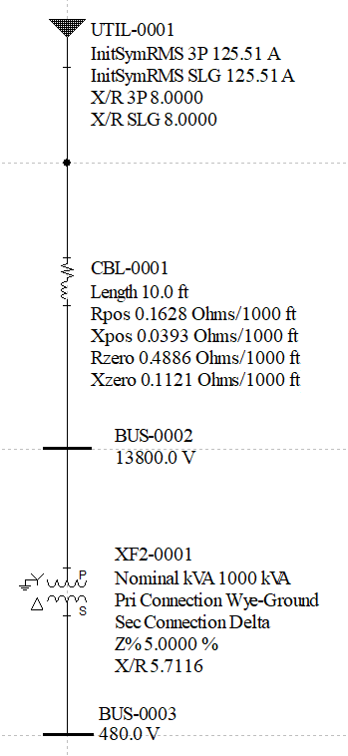

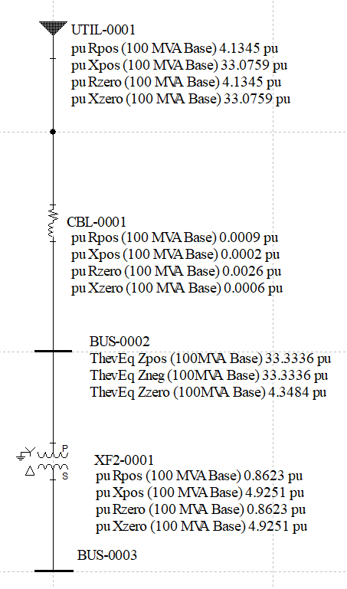

Positive, negative and zero sequence impedance diagrams for a fault at Bus-0002:

Positive:

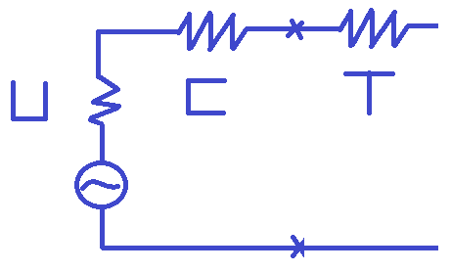
Z₁ is equal to the Utility positive sequence impedance.
Therefore:
Z₁ = 33.3336

Zero:

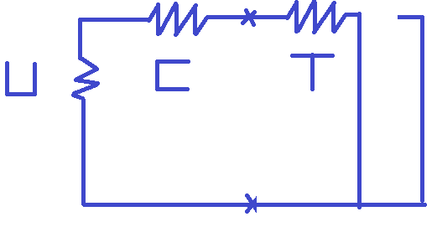
Z₀ is practically equal to the Transformer zero sequence impedance because the Utility impedance is huge.
Therefore:
Z₀ = 4.3484
.
Negative:

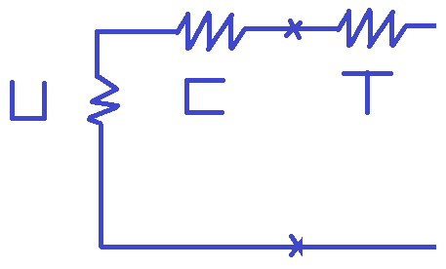
Z₂ is equal to the Utility negative sequence impedance.
Therefore:
Z₂ = 33.3336

Interconnected sequence networks with Z_{F} = 0:

One-line with the Thevenin Equivalent impedance at Bus-0002:

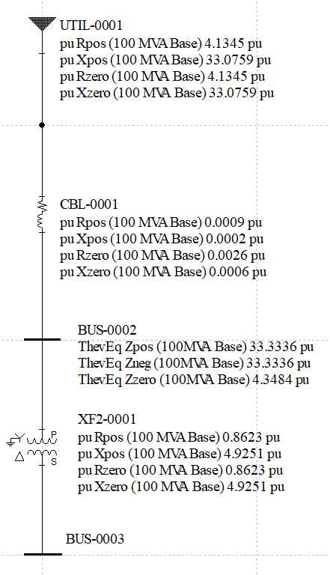

Equation to calculate the Single Line to Ground fault:
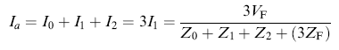

In our example Z_{F} = 0, therefore:

Ia = 3 / (33.3336 + 33.3336 + 4.3484) = 0.0422 pu

The base current at Bus-0002 is equal to the following:

Ibase = 100MVA / (1.732 * 13800) = 4183.7 A

The Single Line to Ground fault at Bus-0002 will be equal to the following:

I = Ia * Ibase = 0.0422 * 4183.7 = 176.74 A

The following is the one-line diagram with the fault current displayed:

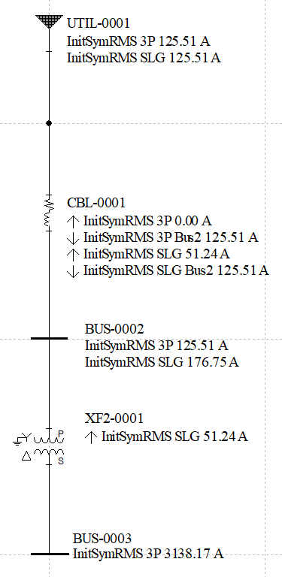

Now we will determine the single line to ground current going through the transformer due to a single line to ground fault at Bus-0002.

Determining the Transformer sequence currents: I_{1T}, I_{2T} and I_{0T}
From the zero sequence diagram, I_{1T} and I_{2T} is equal to zero

Zero:

Positive:

Negative:

From symmetrical components we know that Ia = I₁ + I₂ + I₀ = 3I₁

From the calculation above:

I₁ = 0.0422 / 3 = 0.01407 pu

Ia_{T} = I_{1T} + I_{2T} + I_{0T}

Ia_{T} = 0 + 0 + I_{0T}

Applying current division in the zero sequence diagram

I_{0T} = I₁ [Z_{0UC} /( Z_{0UC} + Z_{0T})]

Z_{0UC} = Z_{0U} + Z_{0C} = (4.1345 + j 33.0759) + (0.0026 + j 0.0006) = (4.1371 + j 33.0765)

Z_{0T} = (0.8623 + j 4.9251)

I_{0T} = 0.01407 (0.8697 + j 0.0055) = 0.0122 pu

The base current at Bus-0002, is equal to the following:

Ibase = 100MVA / (1.732 * 13800) = 4183.7 A

Ia_{T} = I_{0T} * Ibase = 0.0122 * 4183.7 = 51.2 A

If you have additional question, please feel free to contact SKM Systems Analysis, Inc. at the number listed below.

